**Suggested Reading:** Bunker (Chapter 3.5) [1], C05 Silicon Drift Detectors for High Resolution High Count Rate X-Ray Spectroscopy at Room Temperature [6], RP Photonics Encyclopedia - Avalanche Photodiodes [7]

**Vocabulary Words:**

**Solid State Detector:** A device which relies on the p-n junction of semiconductor materials to detect ionizing radiation

**Quantum Efficiency:** A measurement of a device’s ability to turn radiation into electric charge. It is a dimensionless ratio between the number of incident photons and the number of charge carries created.

**Dead time:** The dead time is the time after a detection event where the device can not record another event. It is best understood as the time it takes a detector to “reset” after each event. While different detectors can have unique contributions to their total dead time, all physical detectors must have some nonzero dead time.

**Exercise:**  Below is a time resolution vs energy resolution graph with logarithmic axes. Assign each type of x-ray detector a position on the graph. Don’t worry about being exact in terms of position, simply try to place them correctly relative to one another. Feel free to write down any qualifying arguments you have about your choices. 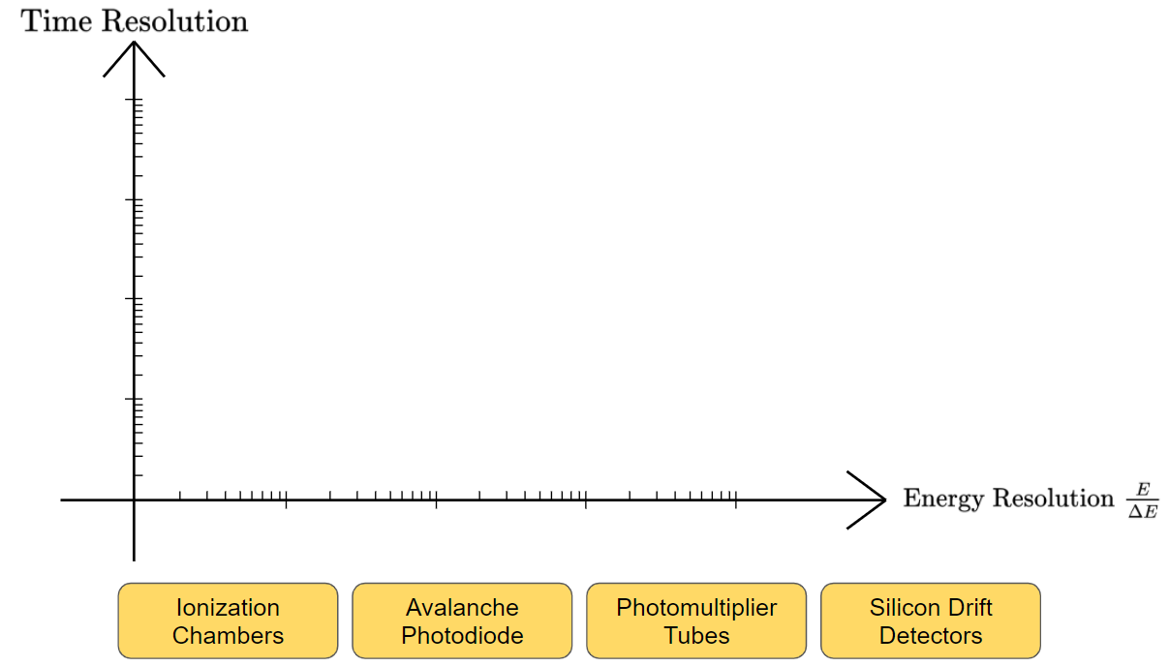

1. Ionization Chambers: These devices generally consist of a pair of voltage biased electrodes separated by an inert fill gas. As x-rays pass through, the inert gas becomes ionized, and the resulting charged particles drift towards the electrodes, inducing a current. This current is measured and can be used to quantify the intensity of the incident x-ray beam.

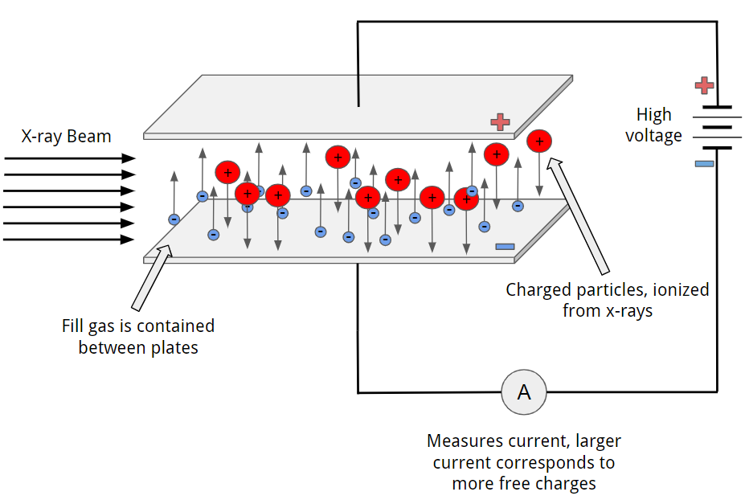

1. The signal current from the electrodes is often quite small, and it is usually amplified and converted to a voltage signal. What intrinsic limitations does this impose on the time resolution of ionization chambers?

It takes a non-zero amount of time to integrate the current and to shape it. This is especially important in so-called “Quick EXAFS” or “Fast EXAFS” where scans are performed over very fast time scales.

1. Below is a graph depicting the dependence of the signal current vs the bias voltage between the two electrodes. What region do we want to operate our ionization chamber in? How does this change depending on the x-ray flux? Ideally we would want to avoid the issue which this graph demonstrates. What is stopping us from cranking the bias voltage up to very large amounts?

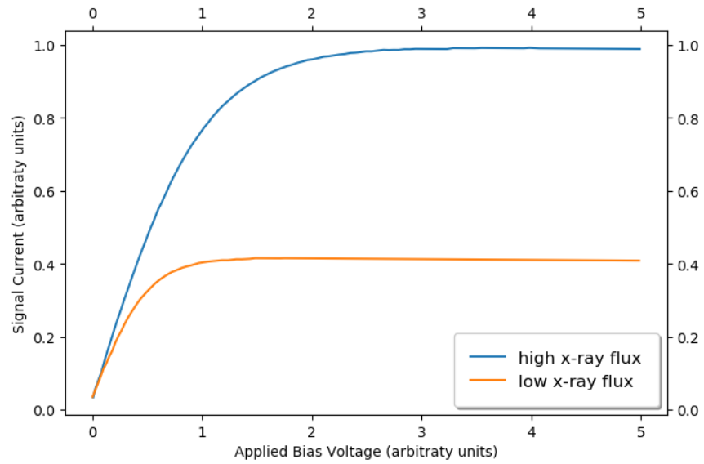

We want to operate in the “flat” region, where the signal current is linearly proportional to the x-ray flux. In the rising portion of the line (about 0 to 1 for the low x-ray flux and about 0 to 2 for the high x-ray flux) the signal current is non-linear with regards to the x-ray flux, meaning that the total current is **not** proportional to the number of x-ray photons absorbed, but also is dependent on the bias voltage. In general, the bias voltage necessary to ensure that the signal current is linearly dependent on the x-ray flux grows with the x-ray flux. If the bias voltage was too high, the charged particles would gain enough kinetic energy to ionize other particles, leading to an avalanche similar to what occurs in geiger counters. This can be controlled to some extent by manipulating the pressure within the ionization chamber.

1. What is the advantage of using an inert fill gas? Why might the choice of fill gas change depending on the energy of the x-ray beam? Why does the physical length of the chamber need to be considered?

If the fill gas is inert, then it won’t be affected by the charged particles created from the x-ray beam. In a non inert gas the free electrons will interact (and potentially bond with) with the other gas molecules around it. This reduces their mobility, and by extension the measured signal. The gas choice is mainly affected by the fact that we need as sufficient amount of the beam to be absorbed so that we can measure a clear signal for , while still having enough to transmit through the sample and be measured by the detector. The ideal amount is for somewhere between %5 to %15 of the x-ray beam to be absorbed. The physical length of the chamber affects the absorption of the x-ray beam, and as such it must be considered when selecting the appropriate fill gas. Given the exponential form of the absorption probability, , a small change in the length of the chamber can have a large effect on the fraction of the beam which gets absorbed.

1. Given your above answers to the above questions, match the fill gas to the correct energy interest. Use the website <http://csrri.iit.edu/mucal.html> ([2], [3]) to find the photoelectric cross section for the fill gas, and the formula to relate the absorption cross section and absorption coefficient. For simplicity, assume that Avagadro’s Hypothesis is correct and that the ionization chamber is 10 cm long.

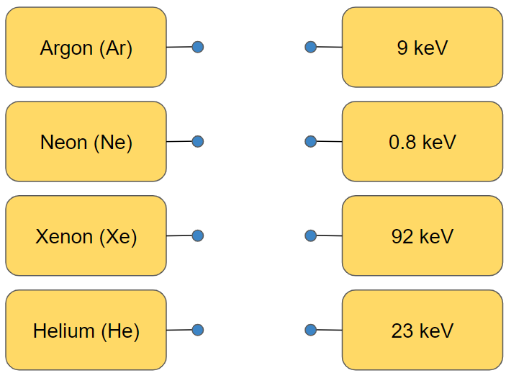

He -> 0.8 keV, Ar -> 23 keV, Xe -> 92 keV, Ne -> 9 keV

1. The standard ionization chamber detector designed for transmission mode is not ideal for measuring the fluorescence mode signal. What additional complication arises in fluorescence mode? How are ionization chambers modified and designed to accommodate this complication?

There is a need for a large solid angle in fluorescence mode measurements, due to the fact that fluorescence is emitted isotropically. With ionization chambers one has effectively no energy resolution, which means that (similar to the setup described in the fluorescence mode section) we must use a combination of soller slits and a Z-1 filter to reduce the signal from other fluorescence lines and scattering background coming from the sample. This setup is sometimes known as a “Lytle detector” [4].

1. Photomultipliers and Scintillators: The working principle behind photomultipliers used for x-ray detectors is based on first converting a high energy x-ray photon into lower energy UV or visible photons through a scintillator. The resulting lower energy photons interact with a photocathode through the photoelectric effect, and the emitted electrons are accelerated through a series of dynodes. At each dynode the number of electrons is multiplied through secondary emission, until the electrons eventually encounter an anode, at which point the signal they create can be measured and related back to the energy of the initial x-ray photon.

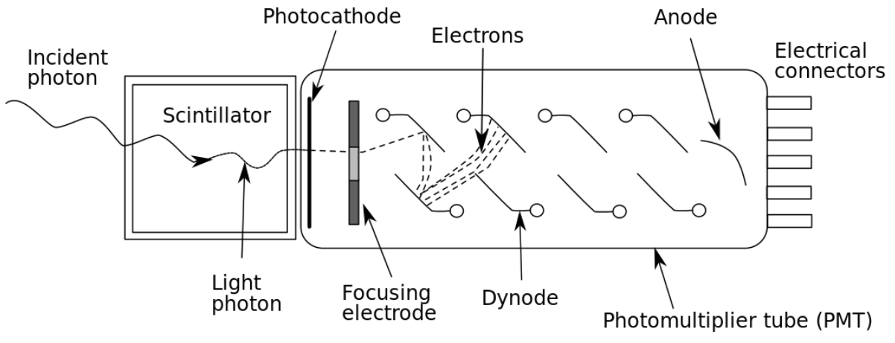

1. In general, how does a scintillator convert the high energy incident photon into lower energy ones?

The high energy photon gets absorbed by the scintillator material absorbs the energy either through the photoelectric effect or inelastic scattering. The excited atoms in the scintillator then fluoresce, emitting multiple lower photons, the number of which is proportional to the energy of the incident radiation.

1. What main advantages does a photomultiplier-scintillator device have over an ionization chamber?

They can be used both as current-mode detectors and as pulse-counting detectors. It also has high quantum efficiency, and superior amplification.

1. What is dark current, what causes it, and why is it important to account for it when looking at the readout from a photomultiplier-scintillator device?

Dark current is the current signal when no radiation is present in the detector. Because there is biasing between the photocathode and each dynode, thermal emission of electrons will lead to some background signal. Additionally, stray radiation (there’s always a little bit) and electronic noise contribute to the dark current value. This value is effectively constant during the course of an experiment, and so it must be measured beforehand and subtracted from the data in post processing.

1. Why is it important to consider the quantum efficiency of the photocathode when constructing a photomultiplier-scintillator device? How is the quantum efficiency related to the photocathode’s thickness?

The QE is the ratio of the number of electrons emitted from the photocathode to the number of photons which hit it. In general, we want the highest quantum efficiency possible so as to extract the most amount of information from the incident photons. There is a tug of war however with regards to the thickness of the photocathode, in that if it is too thick, more photons are absorbed, but less electrons will be able to make it out the other side. If it is too thin, then too few photons will be absorbed.

1. Why are magnetic fields a concern for photomultiplier tubes? What can be done to accommodate for this?

If strong enough magnetic fields are located near the photomultiplier tube, electrons can be curved away from the dynodes, reducing the gain of the entire system. This can be mitigated by magnetic shielding with mu-metals, but this can only usually compensate for static or low frequency magnetic fields.

1. Silicon Drift Detectors (SDDs): SDDs are similar to photomultiplier tubes in that they are pulse-sensitive and can measure individual photons. They are solid state detectors which are effectively specialized photodiodes. The energy of incident x-rays can be determined by the quantity of charge carriers they produce. One of the main advantages of SDDs is in the size of the anode, which collects and measures the voltage from the charge carriers, relative to the active area of the detector.

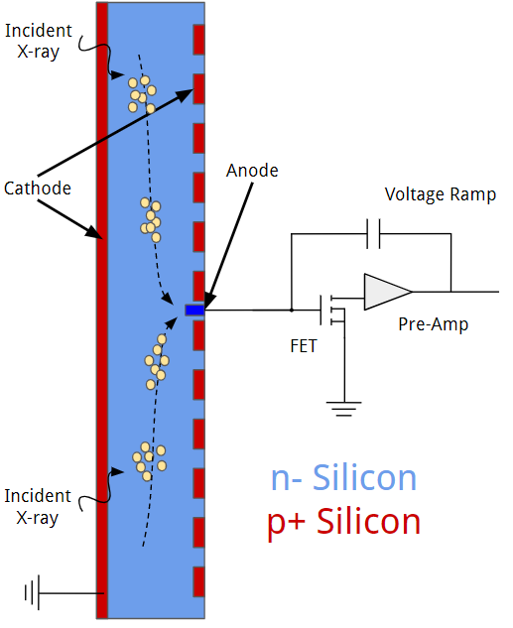

1. See the diagram above. In a real SDD the field effect transistor (FET) is integrated directly onto the surface of the Silicon detector. Why is this?

Less wires, reduces capacitance.

1. How is the FET used in the operation of an SDD? What role does it play in the data acquisition process?

When the electrons (freed by the ionizing radiation) reach the anode, the voltage they create changes the current in the drain leg. This acts as a preamplification step that occurs before the signal is input into a pulse processor.

1. The size of the anode (relative to the active area) has a direct effect on the electronic noise. In general terms, why is this?

The capacitance is reduced by having a smaller anode. The electronic noise is proportional to the capacitance squared.

1. How does the low noise in SDDs allow them to operate at (relatively) higher temperatures than other solid state detectors?

Because the electric noise is dominated by shot noise, there is not much reason for cooling the detector to liquid nitrogen temperatures. Therefore, they can still operate remarkably well at higher temperatures.

1. While SDDs can operate at higher temperatures effectively, they still must be cooled. However, another advantage they have over other solid state detectors is in *how* they are cooled. What advantage is this, and why is it such an important advancement compared to conventional solid state detectors?

SDDs can be cooled via Peltier cooling, a form of thermoelectric cooling, which eliminates the need for conventional liquid nitrogen cooling found in Si(Li) or Ge(Li) solids state detectors. Overall this reduces the cost and maintenance requirement for operating SDDs compared to conventional solid state detectors.

1. Based on your answer to part B, what is about SDDs that give them excellent energy resolution compared to something like the photomultiplier-scintillator devices?

The low noise -> higher energy resolution in terms of E over delta E

1. Avalanche Photodiodes (APD): These devices are in some ways a combination of the working principles behind solid state detectors and photomultiplier tubes. A large reverse bias is applied across a p-n junction. When ionizing radiation enters the device, it leads to an avalanche effect where electrons accelerated by the large reverse bias collide with the medium, creating more and more free electrons, leading to significant current gain.

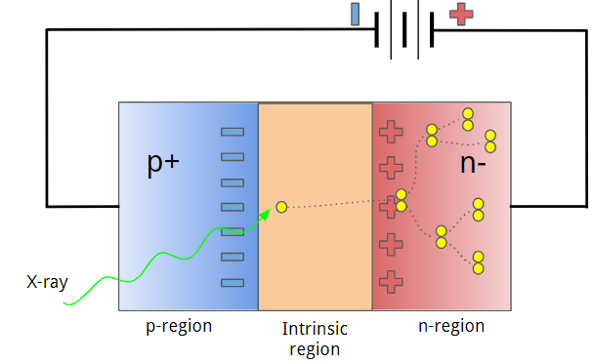

1. Explain in general terms the energy resolution vs time resolution trade off in these kinds of detectors.

Similar to what we discussed with SDDs, the energy resolution is strongly tied to the noise. The avalanche of electrons that is created takes a certain amount of time to reach the anode and be detected. However, the shorter the distance between the cathode and the anode, the greater the capacitance and therefore the greater the resulting noise. Therefore there is a trade off between the energy resolution and time resolution of these devices.

1. What is the main advantage of an APD over conventional photodiodes.

The high reverse bias voltage leads to very large current gain, providing a much greater level of sensitivity.

1. What does it mean for an APD to be operated in “Geiger mode”? Why does this mode require an electronic quenching circuit?

Geiger mode is where the APD is operated slightly above the breakdown threshold voltage, such that a single quantum of radiation can trigger an avalanche. This is ideal for single photon detection. However, once the avalanche is started it must be quickly quenched so that the diode can quickly be able to detect further photons. This contributes significantly to the dead time in this mode.

1. Position sensitive detectors (PSDs)
2. Consider the focused x-ray beam in the diagram below. The x-ray beam is “white” in that it contains many different wavelengths. When it hits a perfect crystal monochromator, reflections will occur at Bragg angles. Using color pencils, draw the reflections for different wavelengths of radiation, with the smallest wavelength (highest energy) being blue and largest wavelength (smallest energy) being red.

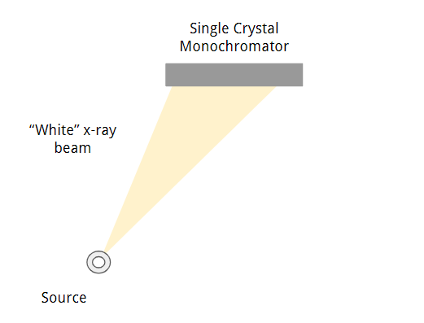

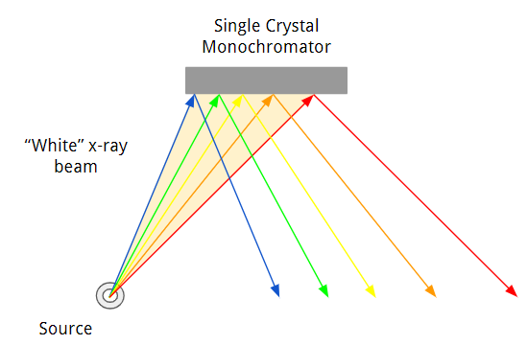

1. What trends do you notice in how the different colors (energies) of radiation reflected off the monochromator? If you were to place a surface parallel to and beneath the monochromator, how would the radiation be distributed on it. Given this, why is a position sensitive detector useful or even necessary for some experiments?

The higher energy radiation reflects off at higher incident angles and vice versa for the lower energy radiation, in accordance with Bragg’s Law. By exploiting this, a PSD can be used to connect the position where the reflected radiation hits the detector with the energy the radiation MUST have as a result of the Bragg condition. This makes PSDs incredibly useful for any experiment that requires the dispersion of incident radiation, and is the fundamental concept behind techniques like dispersive XAFS.

1. One of the first PSDs is considered to be photographic film, such as the kind used by Röntgen to photograph his wife’s hand in the late 1800’s. Since then devices such as bubble chambers, spark chambers, and streamer chambers have been used for detecting ionizing radiation, but it wasn’t until the 1968 when Georges Charpak invented the multi-wire proportional chamber [5] that a detector achieved something close to the position sensitivity that many modern day x-ray experiments require.

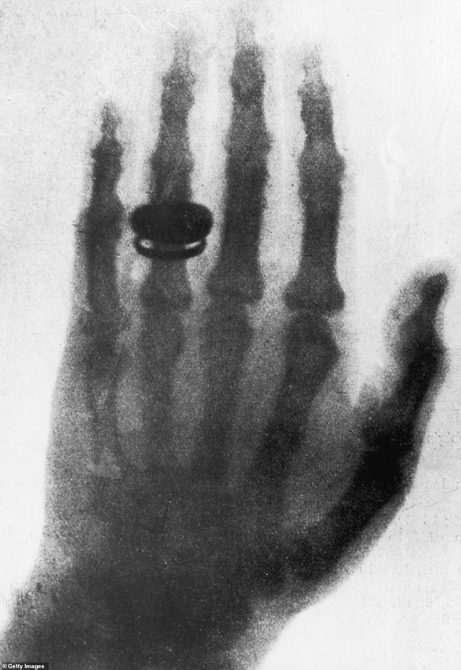 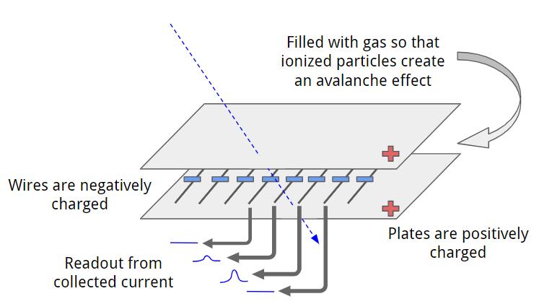

Compared to the historical examples mentioned above, what advantages do newer PSDs such as the charge-coupled device (CCD) and the Complementary Metal Oxide Semiconductors (CMOS) provide?

Less dead time, more position resolution, easier maintenance and manufacturing.

Note: In general position sensitive x-ray detectors are their own class of devices and include a broad range of instruments depending on the desired energy, time, and spatial resolution among other experimental requirements.

Citations:

[1] Bunker, Grant. *Introduction to XAFS: a Practical Guide to X-Ray Absorption Fine Structure Spectroscopy*. Cambridge University Press, 2010

[2] McMaster, W H, Del Grande, N K, Mallett, J H, and Hubbell, J H. COMPILATION OF X-RAY CROSS SECTIONS.. United States: N. p., 1969. Web.

[3] *Mucal on the Web*, csrri.iit.edu/mucal.html.

[4] Lytle, F.w., et al. “Measurement of Soft X-Ray Absorption Spectra with a Fluorescent Ion Chamber Detector.” *Nuclear Instruments and Methods in Physics Research Section A: Accelerators, Spectrometers, Detectors and Associated Equipment*, vol. 226, no. 2-3, 1984, pp. 542–548., doi:10.1016/0168-9002(84)90077-9.

[5] Charpak, Georges. “Particle Detectors and Society.” *Prestigious Discoveries at CERN*, 2003, pp. 135–145., doi:10.1007/978-3-662-12779-7_10.

[6] Lechner, P., et al. “C05 Silicon Drift Detectors for High Resolution, High Count Rate X-Ray Spectroscopy at Room Temperature.” *Powder Diffraction*, vol. 18, no. 2, 2003, pp. 175–175., doi:10.1154/1.1706959.

[7] Paschotta, Dr. Rüdiger. “Avalanche Photodiodes.” *RP Photonics Encyclopedia - Avalanche Photodiodes, APD, Photon Counting, Geiger Mode, Multiplication, Photodetector*, RP Photonics, 4 Oct. 2020, www.rp-photonics.com/avalanche_photodiodes.html.